Know Your Camera

Camera Basics

While the brands, styles and types of cameras are myriad, all have basically the same essential components. Generally speaking, the more elaborate (expensive) the model, the more extra features and capabilities it will have.

All cameras are light-tight boxes with a hole to allow light in and a film or digital sensor to record the image on. A shutter is used to open and close the film/sensor compartment at the beginning and end of the exposure time. These are the essential features of all cameras. All other additions, including lenses, are refinements increasing the efficiency, accuracy and effects achievable with the particular model you have. Of course, it is of no use to have all the gizmos if you don’t know how to use them! This is a brief list of the main components and what they do.

- Lens - Controls Focus, Aperture, Zoom
- Aperture - Controls amount of light onto sensor
- Viewfinder - SLR views TTL (Through The Lens), Compacts have Parallax view
- Shutter - Controls length of time light gets onto sensor
- Sensor - Absorbs light to record image
- Light Meter - Reads light reflected from subject
- Buttons/Dials - Exp. Modes, Flash, Timer etc.
- LCD Panel - Displays current settings
- LCD Screen - Displays recorded images, menus, info etc.
- Flash/Hot-shoe - Built-in/Flashgun

The diagram below shows the path the light takes through an SLR camera.

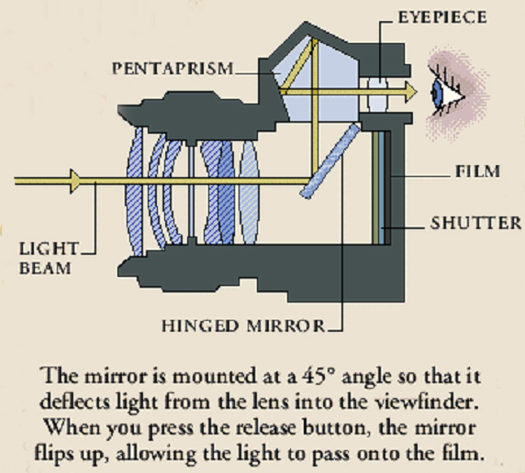
/ SENSOR

Lenses also come in various types and sizes as indicated below (Full frame cameras):

- Manual or Auto-focus

- Prime or Zoom

- Super-Wide (Fisheye 8-14mm)

- Wide (16-28mm)

- Standard (35-50mm)

- Telephoto (>70mm)

- Zooms (28-80, 75-300mm etc.)

Shooting Modes:

- Full Auto (A) – Point & shoot – photographer has no control. Aperture, shutter & ISO set by camera
- Programme (P) – Some control - As Auto but you can shift aperture/shutter combination
- Aperture Priority (A or Av) – You select desired aperture, camera selects shutter speed to match
- Shutter Priority (S or Tv) – You select shutter speed, camera selects aperture to match
- Manual (M) – Full control. You set Aperture, shutter speed, ISO etc.

Other Semi-Auto modes:

- Portrait – Selects wide aperture to blur background
- Close-up/Macro – Selects small aperture to increase depth of field
- Landscape - Selects small aperture to increase depth of field
- Sports/action – Selects fast shutter speed to freeze action

Basic Settings you should familiarise yourself with:

- Adjust Dioptre for viewfinder
- Set image quality
- Set ISO rating
- Set focus point/s
- Set Single frame / Continuous shooting
- Set the self-timer / attach cable release
- Set autofocus mode/manual focus
- Selecting metering modes
- Set exposure compensation to + or -
- Set white balance
- Turn Image Stabilisation on/off
- Set LCD brightness
- Set image rotation
- Understand each shooting mode on the dial

