COMPOSITION
Making Your Images Work

Good composition arranges the elements in an image in a way that is pleasing to the eye. Often the viewer will not be aware of why they find the image pleasing… it will just “feel” good to look at.
Good composition enables the viewer to “read” the image, leading them through the scene and / or telling them a story without words.
Key Elements
The key elements to be considered regarding composition are:
- Format – Portrait or Landscape, Square, Letterbox, Panorama etc.
- Main subject / Focal point
- Foreground / Middle / Background
- Balance
- Viewpoint
Aids to Composition:
- Rule of Thirds
- Leading lines
- Internal frames
- Visual weight / Balance
- Complementary colours
Rule of Thirds:
The intersection points shown are strong positions within the frame on which you can place your subject or main focal point. Placing it in the centre of the frame only works well for symmetrical and frame-filling subjects. Although known as the Rule of Thirds, it is just a guideline and will not work for every image. Once aware of the rule, you will find ways to break it successfully.
Divide Frame into Thirds
Horizontally and Vertically
A B

C D
Place main subject on an
intersection point
A, B, C or D.

This rule is good for:
- Foreground / Middle / Background
- Horizon on upper third – Foreground dominant
- Horizon on lower third – Background / Sky dominant
- Works in both Landscape and Portrait formats
Framing

Leading Lines:
Lines, actual or implied, that lead the viewer’s eye to the main subject of the image.

Examples
- Roads
- Fences
- Open gates/doors
- Rivers
- Shorelines
- Person’s line of sight
- Object’s direction of travel
- Architectural Lines

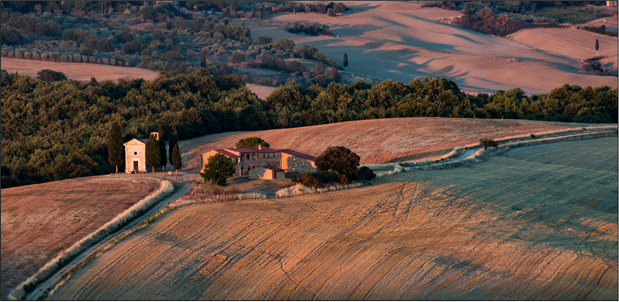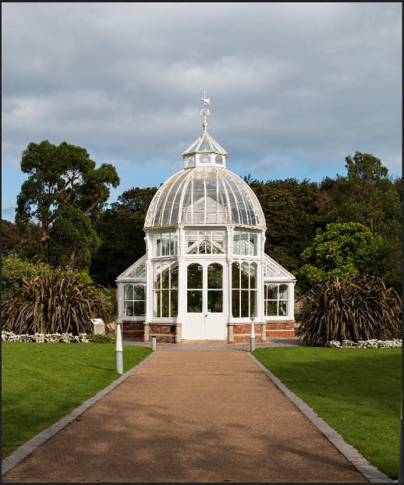

Balance:
If the main point of interest is very dominant, use a second point of interest to balance the image.
Eg: Lakeside castle with swans in the foreground or pyramids with camels approaching.

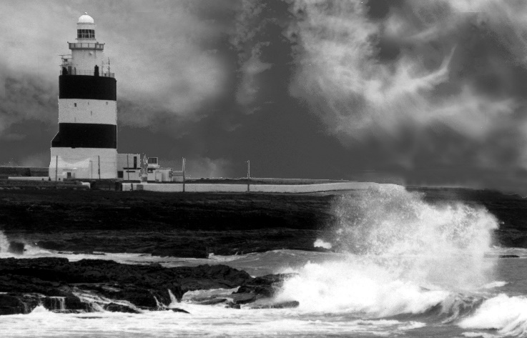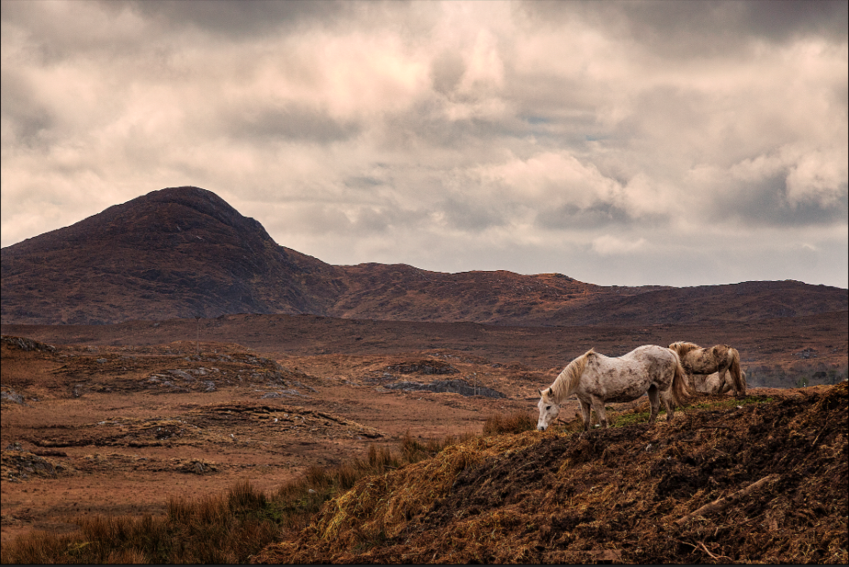

Symmetry
Symmetry is also very pleasing to the eye. We like the feeling of how perfect true symmetry looks. Not always achievable in the real world, but we can try.

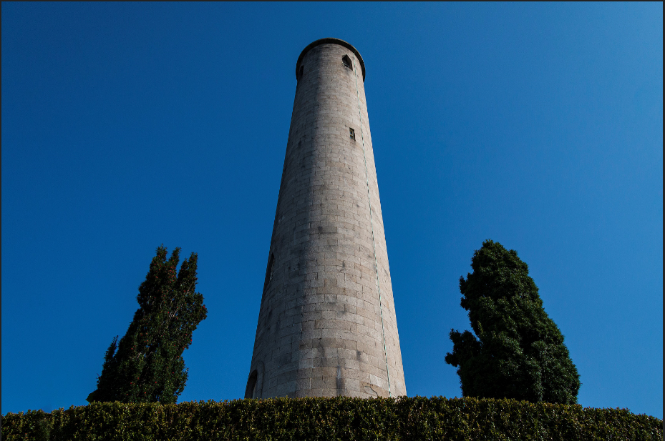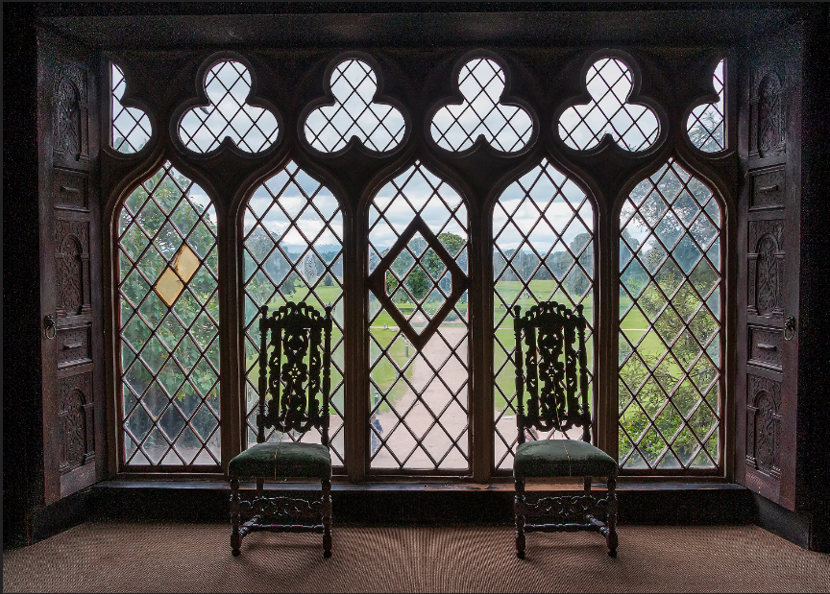

Viewpoint:
Try using different viewpoints to give your images more impact, instead of shooting from the usual standing upright position. Very important to get to subject eye level if possible when shooting kids and wildlife.
Eg: Kneeling, lying down, climb to higher viewpoint. Use a different camera angle.

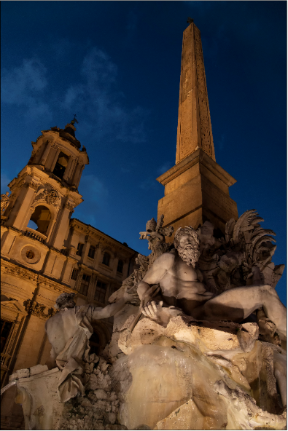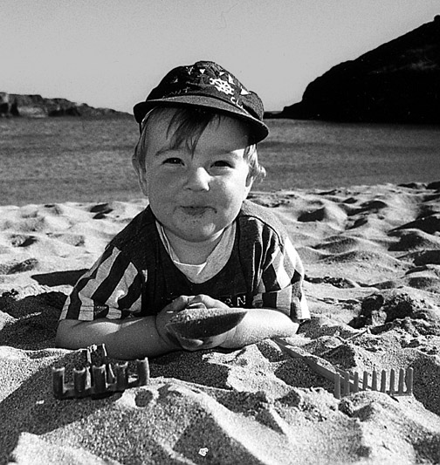

Scale
Including something immediately recognisable in wide view images conveys the size and scale of the elements in the scene. A person, a tree or a vehicle etc. are useful for this.

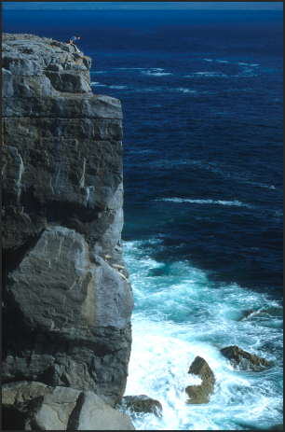

Framing
Sometimes using or creating a frame around your subject can work well. Existing door or window frames or having tree branches filling part of a bland sky are examples.
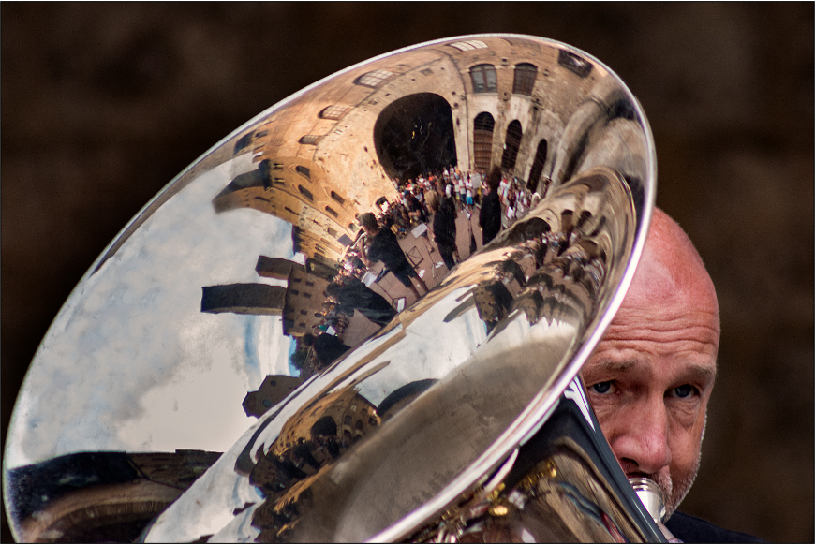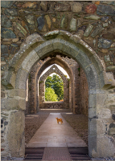

Negative Space
Negative space can be used creatively to bring more emphasis to the subject, to give the subject more “breathing room” or a space for the subject to “move into”.
