Introduction To Basic Editing

Software Suggestions:
- Adobe:
  - Photoshop CC package (€12.99 pm – includes Lightroom, ACR & Bridge)
  - Lightroom CC / Classic (Separate package)
  - Photoshop Elements (c. €102)
  - Photoshop Express – Android / Apple (Free)
GIMP - Google Photos - Snapseed (Free)
ACDSee Photo Studio ($60 approx.)
Capture One ($299)
ON 1 Photo Raw ($80)
DXO PhotoLab 2 ($130)
Corel Paint Shop Pro X9 ($80)
SkyLum Luminar 3 ($70)
Topaz Studio 2 ($100)

There are numerous tutorials for all of these on YouTube. For PS and Lr I recommend PTC (Photoshop Training Channel), f64 Academy, Photoshop Café, PixImperfect (watch out for the monobrow!) and PHLearn.

User Interface / Screen Layout
Most, if not all these programs will have similar components to Photoshop, just laid out slightly differently or with different properties associated with some tools. PS and Lr have built-in tutorials on many tools and methods you can use.
Although they may be laid out differently in each application, the main areas in most programme screens will be:
  - Work / Image area
  - Toolbox – Select individual tools – Brushes, selection tools etc.
  - Tool properties – Options for the currently selected tool
  - Tabs Panel – Colour / Histogram / Nav. Window / Plug-ins etc.
  - Adjustment / Layer Styles Panel
  - Layers / Channels Panel
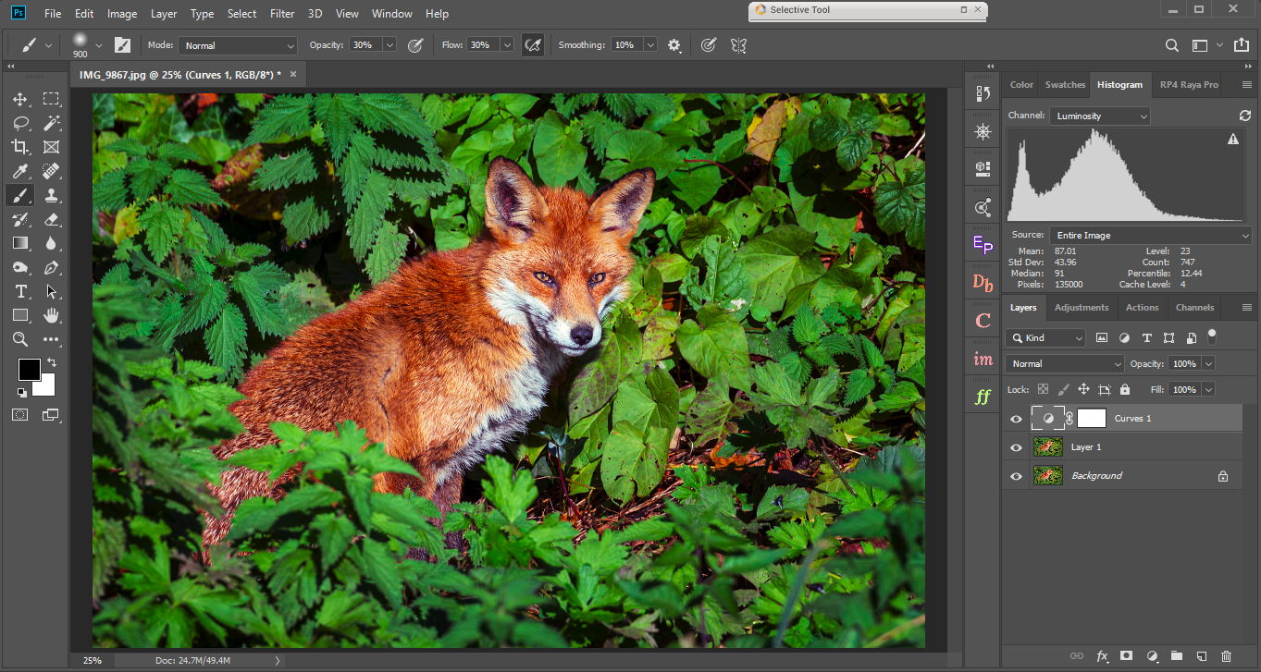
F
E
D
C
B
A

A: Toolbox B: Tool Properties C: Histogram/other tabs panel D: Layers Panel E: History F: Plug-Ins

The tools can be classified as:
- Selection Tools – Marquee, Lasso, Quick Selection, Magic Wand etc.
- Editing Tools – Crop, Clone, Brush, Healing Brush, Dodge, Burn etc.
- Others – Zoom, FG/BG Colour, Screen Mode etc.
Once you are familiar with the interface, the best way to learn is by doing. You can always undo things you have done (as long as you don’t save the changes) and every step that doesn’t work out is something learned.
Below is a suggested workflow for processing an image. You will develop your own workflow preferences as your editing skills and photography styles develop.
- Straighten if required – Use horizon or vertical line in image as guide
- Adjust Exposure – If under/over exposed or adjust shadows/highlights to taste
- Adjust White Balance – if colour cast is present eg: tungsten/fluorescent light
- Adjust contrast – especially if lighting looks flat
- Adjust colour – if required
- Crop if required – for better composition/impact
- Dodge / Burn – if required
- Resize – to optimal dimensions and resolution for printing or screen
- Sharpen – Only after the resize step. Do not over-sharpen
- Print

It is highly recommended that you shoot your images as RAW files. If you feel you do not yet have the knowledge to process RAW files, then select the RAW + JPEG option in the Image Quality menu on your camera. This will allow you to go back at a later time, as you will also have a RAW file of your image, and be able to produce a far superior print from that file when your skill level has improved.
RAW Files:
- Full, uncompressed, unedited image data.
- Always looks “Flat” compared to jpeg file
- Must be edited to reveal detail
- Greater dynamic range than Jpegs
- Non-destructive editing – retains original data
- Edited file saved in other formats
- Most work can be done in RAW software
  - Adobe Camera Raw, Digital Photo Professional (Canon), NEF (Nikon) etc.
- Finish in editing software - PS, Lr, Luminar, Topaz etc.

I will give a demonstration on processing a RAW file in the next session. Below is an example of how much detail can be brought out in a RAW file in Adobe Camera Raw only. Proportions of the processed image are only different due to cropping.
Before After
